UJIAN TENGAH SEMESTER

SEMESTER GASAL 2024-2025

PROGRAM SI / Prodi AKUNTANSI

Mata kuliah: Systems Analysis and Design

Untuk : kelas prodi Akuntansi S1

Tanggal : 15 Oktober 2024

Dosen: Dr. Totok Dewayanto, SE, MSi, Ak, CA, CertDA

OPEN BOOK

----------------------------------------------------------------------------------------------

1. Lihat dari buku Systems Analysis and Design dari Chapter tentang DFD, Relasi Data, dan UML, buatlah contoh kasus sistem dengan penyelesaian dengan DFD, ERD, dan UML Diagram(class, sequent, use case dsb) dengan menggunakan Draw.io

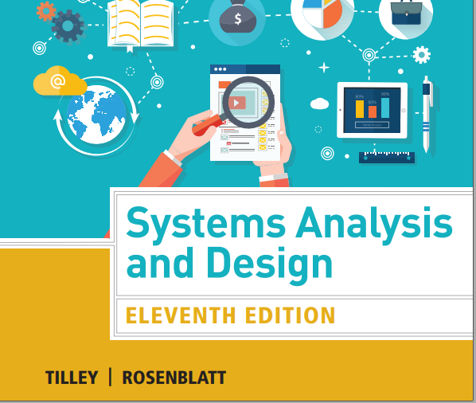

Hasil pekerjaan silahkan diupload ke Google Drive dan link dikumpulkan oleh Ketua Kelas dan oleh ketua kelas dikirim ke: [dewayanto1969@gmail.com](mailto:dewayanto1969@gmail.com)

(Pengumpulan paling lambat pada tanggal ujian 15 Oktober 2024 jam 12.00)

**NAMA :** KEISSA SHAFARA PUTRI WIBOWO

**NIM :** 12030123140337

**KELAS :** C

**NO. ABSEN :** 35

**Case in Point 4.1: North Hills College**

North Hills College has decided to implement a new registration system that will allow students to register online, as well as in person. As IT manager, you decide to set up a JAD session to help define the requirements for the new system. The North Hills organization is fairly typical, with administrative staff that includes a registrar, a student support and services team, a business office, an IT group, and a number of academic departments. Using this information, you start work on a plan to carry out the JAD session. Who would you invite to the session, and why? What would be your agenda for the session, and what would take place at each stage of the session?